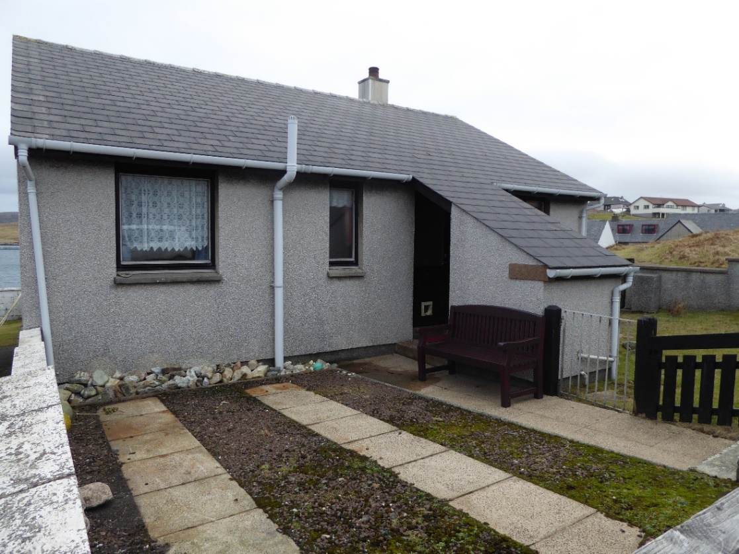

13 ATLANESS, HAMNAVOE, BURRA

Detached two bedroomed former Council House in move in condition with Easterly aspect, off road parking and garden ground to the south and east, including the drying green. It is situated a short walk from the local shop & primary school in the village of Hamnavoe on the Island of Burra which is linked to mainland Shetland by fixed bridges via the neighbouring Island of Trondra. Scalloway 5 miles; Lerwick 11 miles.

EPC RATING Band D (65)

PRICE Offers over £142,000

VIEWING Contact our Reception

ACCOMMODATION Vestibule, Entrance Hallway Living Room, Kitchen/Diner, 2 Bedrooms and Bathroom/ Shower Room.
13 ATLANESS, HAMNAVOE, BURRA, ZE2 9XW

The heart of Hamnavoe is its harbour, complete with its pier. Here you can seen a selection of fishing vessels and pleasure craft. The pier is also one of the best places from which to get a sense of the layout of Hamnavoe, which is spread over the hillside above Hamna Voe in a way that is difficult to appreciate from many parts of the village.
A number of walks take in the best of the nearby coastal scenery. One excellent excursion leads around Hamna Voe to the lighthouse on Fugla Ness. This again offers good views of the village, together with a glimpse of the distinctive profile of the island of Foula rising from the Atlantic to the west. South of Hamnavoe is a car park close to the Sands of Meal, felt by many to be one of Shetland's best beaches.

The property is set in its own garden ground including drying green.

Heating is oil fired central heating with radiators in the Hallway, Kitchen, Sitting Room, both Bedrooms and Bathroom.

The Shed opposite the front door contains the central heating boiler with space for automatic washing machine/tumble dryer and garden equipment and also housing the letter box. A large plastic fuel tank is bunded with low risk level 2.

Accommodation comprises:

VESTIBULE – Approx. 1.99m x 1.28m
Housing the electric meters and coat pegs.

ENTRANCE HALLWAY – Approx. 2.3m x 3.4m
This L shaped area includes a radiator and central heating thermostat controls. Leading to the following rooms – Kitchen/Diner, Sitting Room, Two Bedrooms and Bathroom/Shower Room. Large walk-in cupboard/Airing Room L shaped – Approx. 1.18m x 1.14m at widest points.

KITCHEN/DINER – Approx. 3.18m x 3.18m
Window facing West. Built in Kitchen units, radiator, space for automatic washing machine, eye level Indesit Oven with cupboards above and below. Walk-in Larder Approx. 1.64m x 1.22m incorporating built-in shelves and space for Fridge and Freezer.

LIVING ROOM – Approx. 4.6m x 3.17m
The double window facing East enjoys sea views with Radiator below. Solid wood burner and shelved recess.

DOUBLE BEDROOM – Approx. 3.54m x 3.18m
With East Facing window overlooking the drying green with sea view. Built in double wardrobe with sliding doors partly shelved and rail for clothes hangers. Radiator.

SINGLE BEDROOM – Approx. 2.33m x 3.05m
West facing window and Radiator.

BATHROOM/SHOWER ROOM – Approx. 1.75m x 1.6m
Wash hand basin, w.c., white bath, tiled shower area over the bath with Triton T80si electronic shower.

